Presenter: Jacob Bernhardt  
Reviewer: Cornel Stoica  
App name: Castle Crusaders  
Course: CST238

Original mock UI:

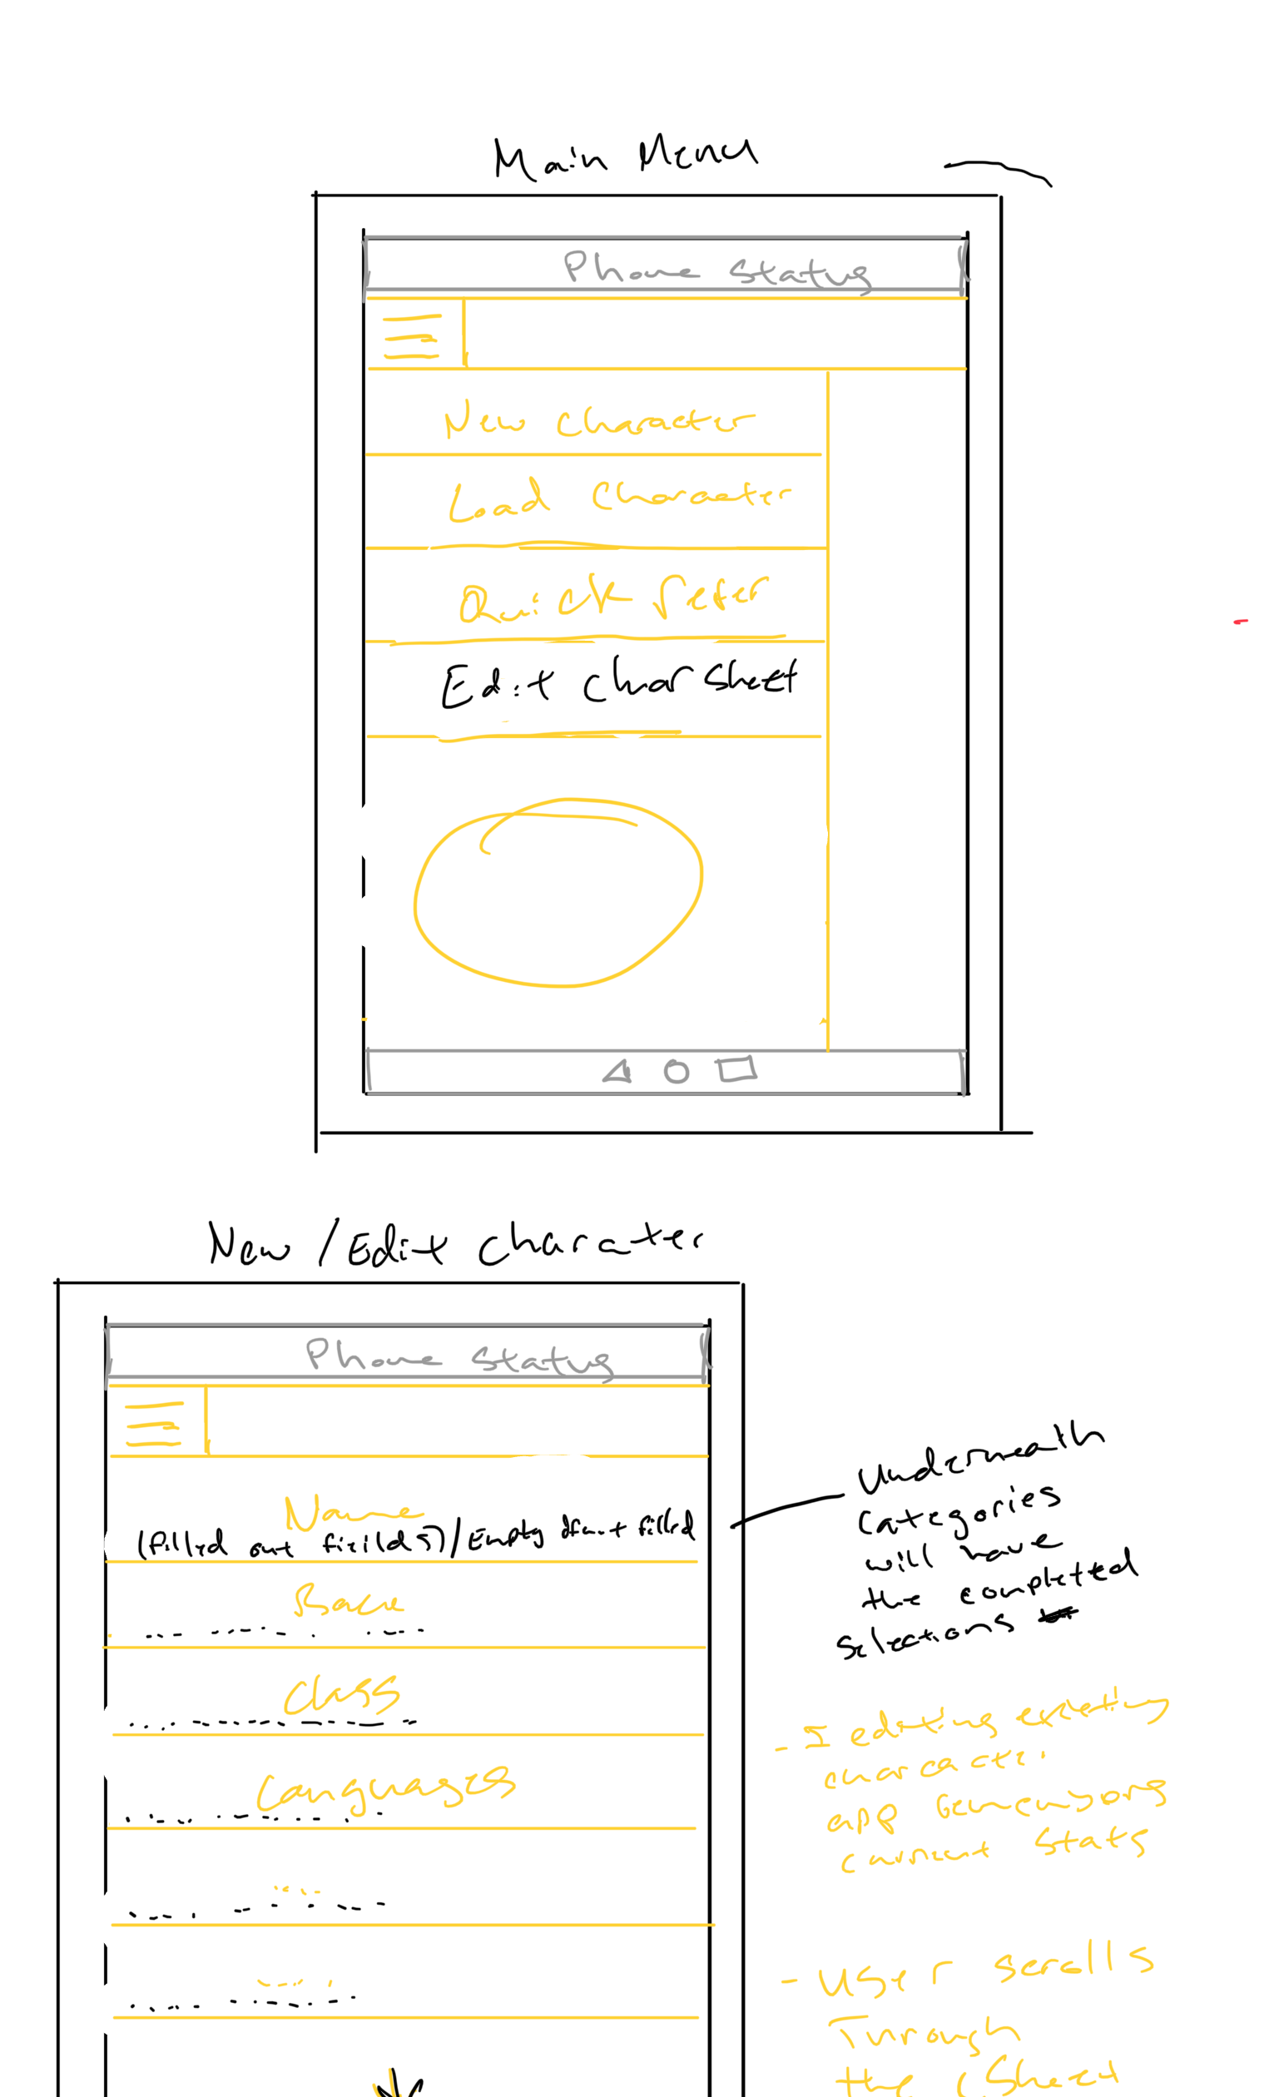

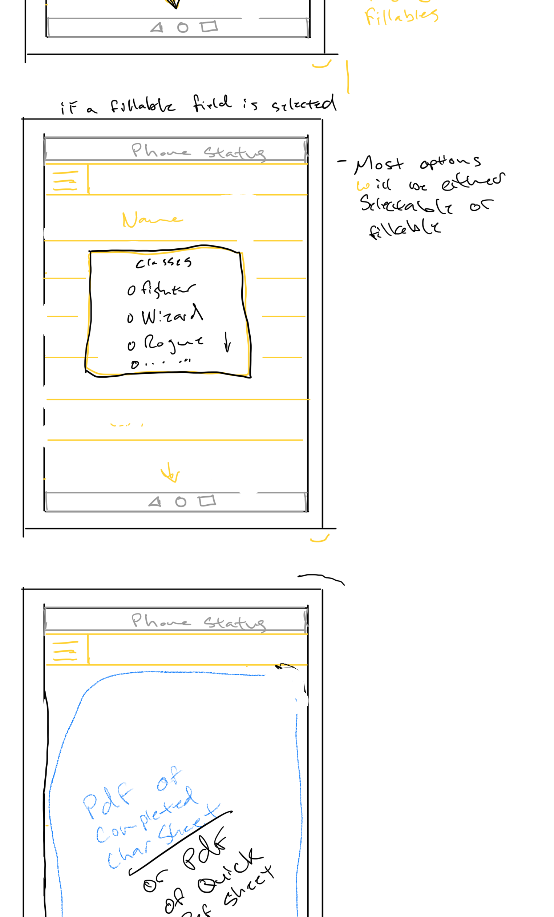

Suggestions:

* Make character options collapsible to make it easier for users to navigate/input info without the added clutter
* Give user the option to share or print completed pdfs
* Instead of character info window overlay popup in the middle, perhaps have it go to next window or to the right (ability to go back and forth)
* Add a number indicator next to each character option to show a preview of possible options available for it

Suggested UI:

